German Shepherd Dog Hock

This is another very important part to discuss when it comes to hind quarters in German Shepherd Dogs. When the GSD is made to stack – like in the show ring – with the left leg pulled back, the hock should be vertical to the ground. While in the stacked position, an atomically sound GSD should have a hock almost parallel to the femur – (NOT perfectly parallel though), thereby making the hock angulation and stifle angulation almost same – around 95 degrees.

Hocks in a trotting breed in German Shepherds are of utmost importance. Any kind of deformities in hock is considered as fault as the propulsive power at the end of a stride on the trot is being transmitted though the joint of the hock. While galloping, both the hock joints generate great force together, which cannot be fulfilled by defective hocks. Similarly while jumping, even higher force is needed to propel the entire body, which cannot be possible with a defective hock.
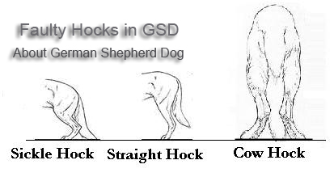
Different Faults in German Shepherd Hock
Straight hocks degrade the quality of strides by shortening the strides to a great extent, thereby checking the speed and ability to jump. Straight hocks are faults in GSD breed.

Sickle hocks, are noticed in many show dogs that have more angulated hock – more acute angulation than the angle of femur. In case of extreme sickle hocks, the metatarsus tends lay almost flat to the ground, which is a serious fault.
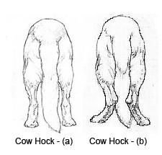

Cow hocks, is again another serious fault in German Shepherds. Cow Hock is a condition where the hocks tend to turn towards each other. Cow hock can be a result of any of the two conditions…
a) Cow hock due to the entire leg turned out from the hip. In this case the dog tends to stand slightly wider on the rear lags, with the stifle and toes slightly extended outward. Such a condition is considered as normal if the bones in the related areas are straight in connection to each other.
b) Cow hock due to twisting inward of the hock and the stifle joints. Such a condition affects the gait or locomotion of the dog, which in turn adversely influence the working ability of the dog. Cow hock due to due to twisting inward of the hock and the stifle joints can only happen if the bones are twisted, which cannot be considered normal. It is a serious fault.

